Homework 2

Assigned: September 16, 2024 (Monday)
Due: September 23, 2024 (Monday)

Problem 1 Write complete pseudo code for enqueue using the incremental strategy for Array based Queue ADT with constant incremental size of c. Find the worst time complexity of your pseudo code in terms of amortized cost.

Problem 2 Consider the implementation of queue ADT with stack ADT. The modified Queue has enqueue and dequeue operations implemented using stack push and pop operations as depicted below:

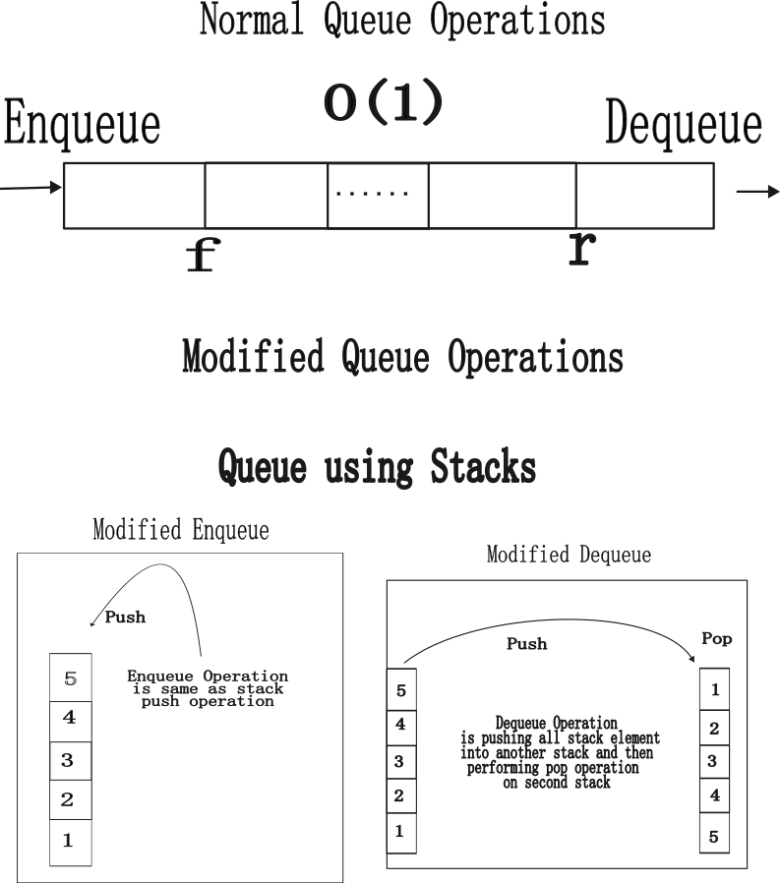

- Figure out the issue with modified Dequeue operation.
- Write the pseudocode of modified enqueue and dequeue operations.
- Analyze the time complexity of modified enqueue and dequeue operations. Make necessary assumptions if required.

Problem 3: Define the following terms:
- Abstract data type
- Data structure
- “The design of the data structure should be based on application and the frequency of the operations. It is ok to have costly low frequency operations as compared to high frequency operations”. Comment on the above statement.
- Why O (1) run time complexity ideal for high frequency operations. Why developers should focus on creating a data structure that enables such operations in O (1).

